Bulk Fuel PO Creation Instructions
for LaGov State Agencies

- Agency generates a Bulk Fuel Pricing Report for the date of the fuel delivery using the application found at https://fuel.la.gov/BulkFuel/bulkFuel.cfm . Instructions for using the Bulk Fuel Calculator can be found on the website https://fuel.la.gov/BulkFuel/bulkFuel.cfm.
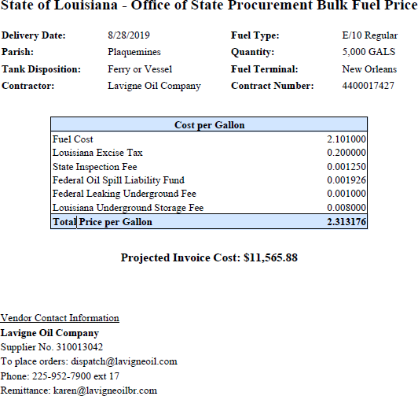
- Agency receives invoice from Contractor and creates a Confirming PO. Base instructions for creating a Confirming Purchase Order can be found in LaGov.

- Agency will add a line to the PO for the fuel delivered by clicking the Add Line button > selecting the SRM MDM Internal Catalog option > clicking the Advance Search button > Entering the contract number provided by the Bulk Fuel Calculator in the Contract ID field > clicking Search.
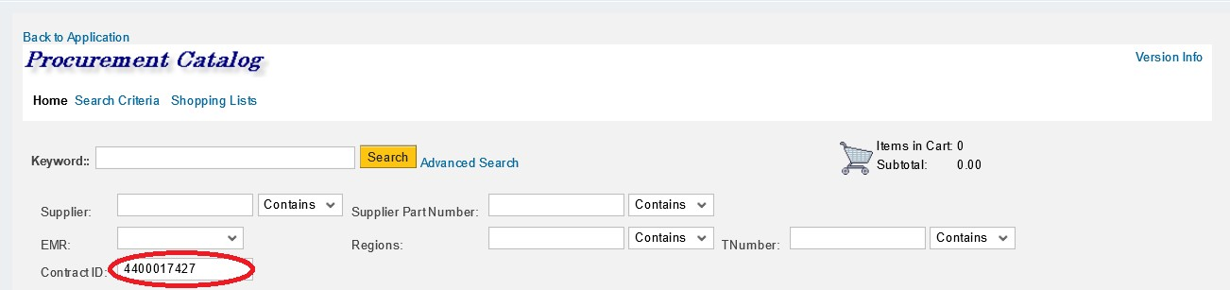

- Agency will select the appropriate line for the fuel type for the order as well as any applicable allowable fees
> click add to cart > click check out.
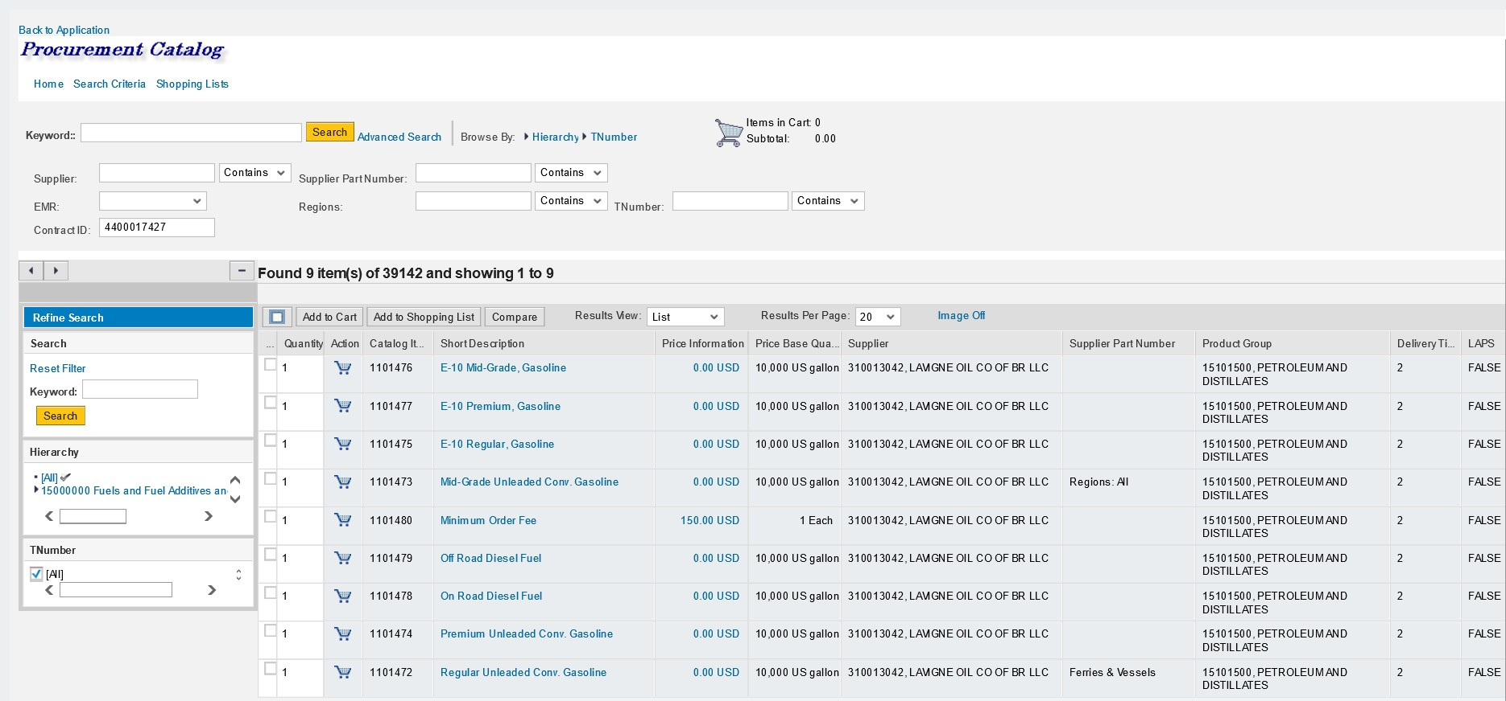

- Agency will enter the total number of gallons and gross price into the fuel line.
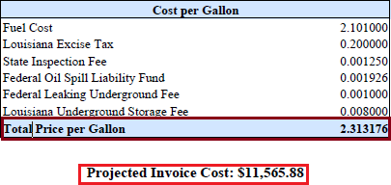

IMPORTANT: In order to calculate the correct Gross Price to enter on the PO you must take the total price per gallon that was generated for the order on the Bulk Fuel Price Report and multiply that number by 10,000 (move the decimal 4 places to the right). This is necessary due to SRM preventing the entry of a price beyond two decimal places. There is a condition that is pre entered on the MDM line that will revert the pricing back to the correct amount. Please see the following example:

2.313176
x 10000
12,131.76
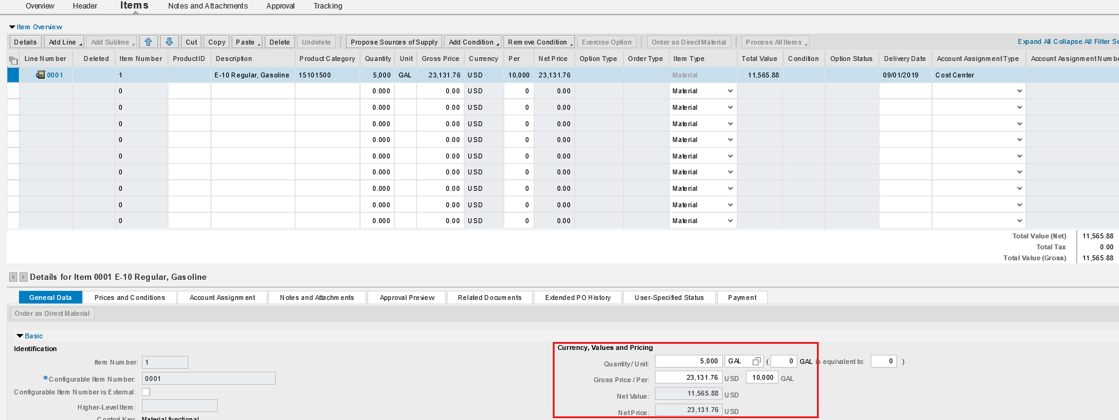
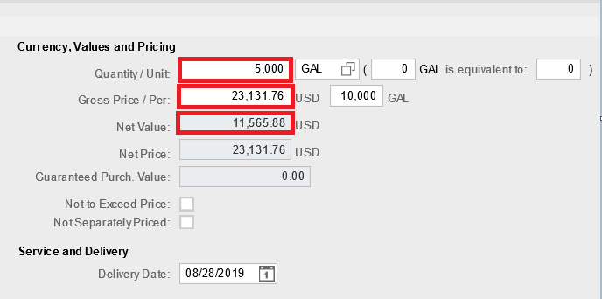

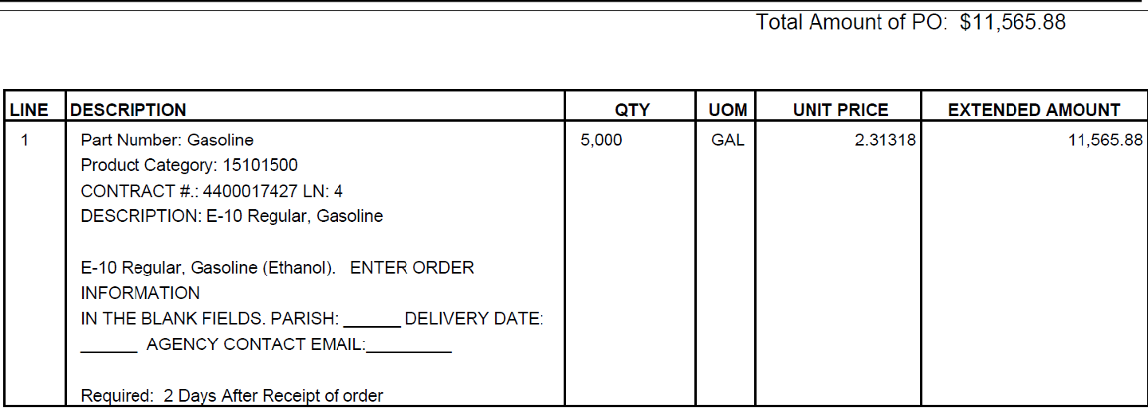

As you can see in the above example when the pricing is entered the correct unit price will be shown on the PO (rounded to the 5th decimal) and the total PO amount will match the Projected Invoice Costs found on the Bulk Fuel Pricing Report.

- If Agency needs to receive fuel into inventory then the Agency will need to manually enter the correct Product ID for the fuel type.
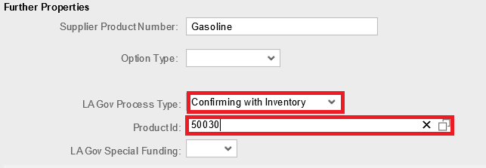

Product IDs:
49900 Fuel, Regular, Unleaded, Ethanol Free
49901 Fuel, Diesel, NRLM Low Sulphur
49902 Fuel, Diesel, Ultra Low Sulphur
49904 Fuel, Premium, Unleaded
49905 Fuel, Prem Unleaded, 10% Ethanol
49906 Fuel, Mid-Grade Unleaded, 10% Ethanol
49907 Fuel, Mid-Grade Unleaded
50030 Fuel, Unleaded, 10% Ethanol

- Agency completes all other required Confirming PO information (e.g. accounting, requestor information) and orders the PO. OSP strongly recommends attaching a copy of the Bulk Fuel Pricing Report for the order to the PO.

IMPORTANT: The pricing provided by the Bulk Fuel Calculator is the maximum allowable amount the Contractor is allowed to charge for an order. There may be small deviations in pricing that cause the Contractor to invoice for less than the amount provided by the Bulk Fuel Calculator. This is acceptable. When this occurs Agencies should remember when paying against the PO that they must select the final invoice option in order to ensure that the leftover PO amount is liquidated. This will prevent a change order from having to be done.

If there are any questions regarding the use of the Bulk Fuel Calculator and/or the use of the fuel contracts please contact Tedrus Paul Phone: 225-342-8047 / Email: tedrus.paul@la.gov.

